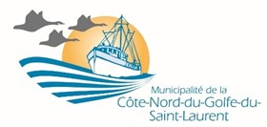
December 2023
NEWSLETTER
_________________________________________________
Email : info@mcngsl.org
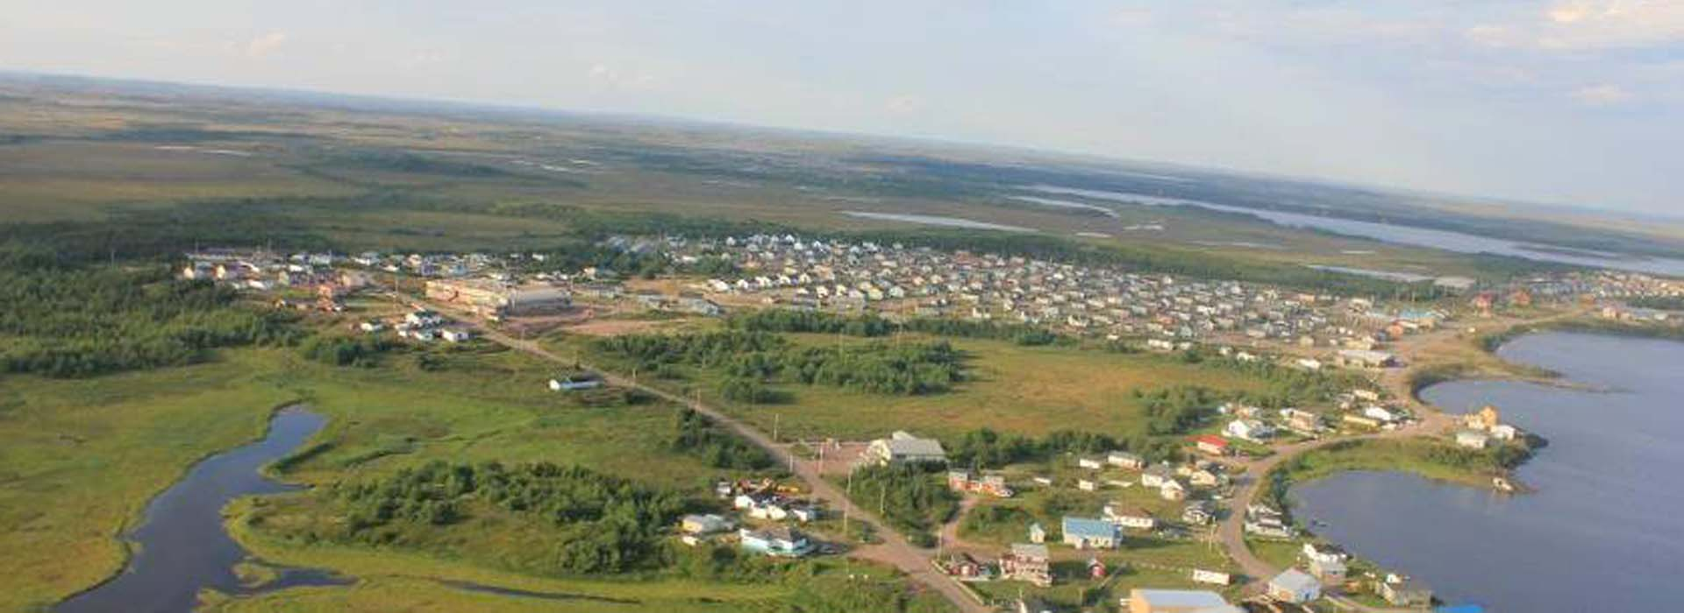
INSIDE :
01.Request for construction permit
Number in case of an emergency
- Public consultations
- Mystery word
- Riddle guess
Vous pouvez consulter la version en français sur la page WEB : mcngsl.ca
La Romaine

Christmas vacation 2023

The entire team of the Municipalité de la Côte-Nord du Golfe du St-Laurent takes this opportunity to wish you all a Merry Christmas with families and friends and a safe and healthy 2024!

Holiday schedule:
Please take note that our office will be closed from
December 21st to January 5th, 2024, inclusively.
The office will reopen on Monday, January 8th at 8: 00 AM.

HAPPY HOLIDAYS

Building Permit Applications
According to municipal laws, all property owners are responsible for applying to the Municipality for a building, renovation or demolition permit before proceeding with any work.

Why apply for a permit? It's simple and it is not for the financial gain to the Municipality, the cost of a residential permit is only $30.

A permit allows you to:
- Increase the value of your home in the event of a renovation or a possible sale;
- Reduce your taxes in the event of demolition;
- In respect to property regulations, a new construction must be registered to receive municipal services.

Also note that for any land application to the MNRF (Minister of Natural Resources and Forests), you must also apply for a certificate of conformity from your municipality.

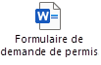
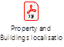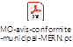

To open these links, please log on to the municipality's website: mcngsl.ca
Under the tab of your village, you will find the newsletter under the ''news'' tab .

For Emergencies, here is a checklist of numbers to contact:

- 911 at all times
For example : there was a fire in an Hydro pole lately between Natashquan and Kegaska. 911 is the number to call, they have all the contacts and are ready to deal with situations like that. It is important to call 911 in case of an emergency.
- 418-787-2246 for a municipal-related emergency
- 310-4141 or *4141 from a cell phone Sûreté du Québec

The Municipalité de la Côte-Nord du Golfe du St-Laurent
The process and work that lead to the recent public consultations

- Between 2018 and 2021, steps were taken with the various local committees to identify concerns and possible solutions to improve the functioning of the municipality.
- In 2022, implementation of a General Committee made up of the five local committee presidents (not officially instituted by MAMH) with a mandate to:
- Propose legislative amendments that take into account the concerns and solutions identified by the local committees
- Suggest improvements to the functioning of the local committees

- In 2023, the General Committee, with the collaboration of the municipality and the MAMH, has identified two possible scenarios for changing the governance structure, which allow a public consultation before submitting a request for changes of the law to the Minister.

As it was mentioned during the presentation, following the public consultation held in your village during the month of November, and December in Kegaska, please be aware that boxes are now placed and ready to receive your comments, your questions and your suggestions. Deadline is January 12th , 2024.

- Kegaska : Post Office

- La Romaine : Municipal house

- Chevery : Post Office

- Harrington Harbour : Post Office

- Tête à la Baleine : Magasin du Portage

We would like to take this opportunity to emphasis how important it is for all citizens to feel involved in the process that has been set in motion. As was confirmed by the MAMH (Minister of Municipal affairs and housing) during the public consultations, the population will have the final say.
_________________________________________________

